CHAPTER 17: DIVING DEEPER INTO TEXT AND FONTS WITH WINAPI

Welcome to Chapter 17, where we'll delve into the fascinating world of text and fonts in the context of WinAPI! As you mentioned, displaying text was our initial foray into graphics programming, and now it's time to refine our skills by exploring:

Font Varieties in Windows: We'll delve into the diverse world of fonts available in Microsoft Windows, including the revolutionary TrueType technology that brought WYSIWYG to life.

Font Manipulation Magic: TrueType's power goes beyond simple display. We'll explore exciting techniques like font scaling, rotation, pattern fills, and even using fonts as clipping regions!

Justifying Text: Learn how to make your text visually appealing by aligning it to the left, right, or center of the window.

Remember, you're currently learning WinAPI, so we'll focus on using its functionalities to achieve these effects. Buckle up and get ready to unleash your inner typography guru!

TrueType: The Game Changer for Text in Windows

The introduction of TrueType in Windows 3.1 marked a significant milestone in text rendering. Unlike older bitmap fonts, TrueType uses mathematical outlines to define character shapes. This offers several advantages:

Scalability: TrueType fonts can be smoothly scaled to any size without losing quality, unlike pixelated bitmap fonts. This is crucial for WYSIWYG, ensuring what you see on screen is what gets printed.



Platform Independence: TrueType fonts work across different platforms like Windows and macOS, promoting compatibility and flexibility.

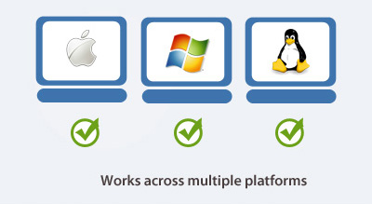

Advanced Features: TrueType's outline-based approach opens doors for exciting font manipulation techniques like:

* Rotation: You can rotate characters to create unique effects.
* Pattern Filling: Fill character interiors with custom patterns for visual flair.
* Clipping Regions: Use font outlines to define clipping regions for other graphical elements.

We'll explore these functionalities later in the chapter, so stay tuned!

Beyond Basic Display: Mastering Text Manipulation

TrueType's capabilities extend far beyond simply displaying text on the screen. With WinAPI, you can unleash your creativity and manipulate fonts in various ways:

Scaling: Change the size of text without compromising quality using functions like CreateScalableFontResource and SetTextScale.

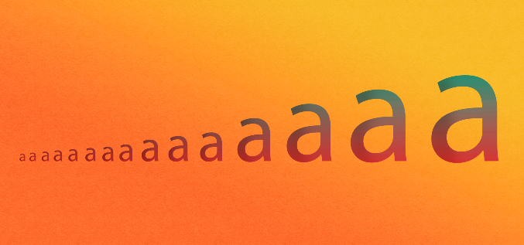

Rotation: Rotate individual characters or entire strings for a dynamic and eye-catching look. Utilize functions like GetGlyphOutline and PolyDraw to achieve this.

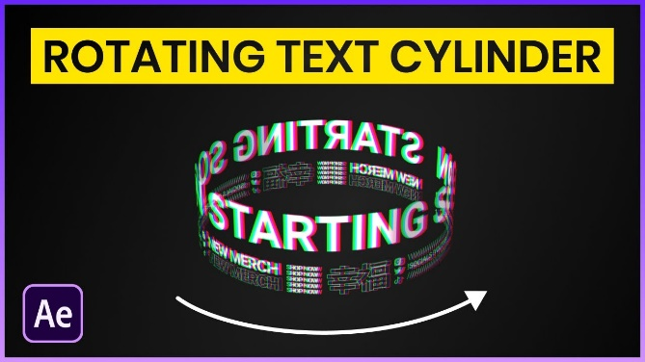

Pattern Filling: Fill the interiors of characters with custom patterns using WinAPI functions like FillPath. Imagine text shimmering with stripes or polka dots!



Clipping Regions: Define clipping regions based on font outlines using functions like SelectClipRgn. This allows you to mask other graphical elements behind the text, creating interesting effects.

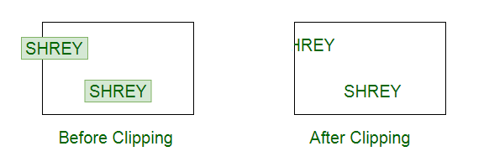

Remember, these are just a few examples. As you delve deeper into WinAPI text manipulation, you'll discover a vast playground for experimentation and creative expression.

Justifying Text for Visual Balance

Justified text, where both margins are aligned, adds a touch of refinement to your applications. WinAPI provides functions like SetTextAlign and GetTextExtentPoint32 to achieve this effect. You can choose left, right, or center alignment based on your desired layout.

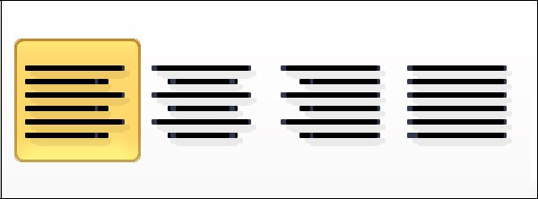

By mastering text justification, you can elevate the visual appeal of your WinAPI applications and create a more polished and professional user experience.

WINDOWS TEXT OUTPUT FUNCTIONS

In Windows programming, text output is facilitated by various functions, and one commonly used function is:

TextOut:



Core function for displaying text.

Arguments:

* hdc: Handle to the device context.
* xStart: Horizontal starting position (logical coordinates).
* yStart: Vertical starting position (logical coordinates).
* pString: Pointer to the character string.
* iCount: Length of the string (not NULL-terminated).

Coordinates and Positioning

The xStart and yStart parameters determine the starting position of the text in logical coordinates.

Typically, Windows starts drawing at the upper left corner of the first character.

The function requires a pointer to the character string (pString) and the length of the string (iCount). Notably, it does not recognize NULL-terminated character strings.

The positioning of the text can be influenced by the SetTextAlign function. Flags like TA_LEFT, TA_RIGHT, TA_CENTER, TA_TOP, TA_BOTTOM, and TA_BASELINE affect how xStart and yStart are used for horizontal and vertical positioning.

SetTextAlign Function

By calling SetTextAlign with the TA_UPDATECP flag, the xStart and yStart arguments in TextOut are ignored.

Instead, Windows uses the current position set by functions like MoveToEx or LineTo.

The TA_UPDATECP flag also updates the current position after a TextOut call, which is useful for displaying multiline text.

Controls horizontal and vertical positioning of text.

Flags:

* Horizontal: TA_LEFT, TA_RIGHT, TA_CENTER
* Vertical: TA_TOP, TA_BOTTOM, TA_BASELINE

TA_UPDATECP flag:

* Ignores xStart/yStart in TextOut, uses current position.
* Updates current position after TextOut (except for TA_CENTER).

TabbedTextOut Function

An alternative to multiple TextOut calls for columnar text is the TabbedTextOut function:



If the text string contains tab characters (\t or 0x09), TabbedTextOut expands the tabs based on an array of tab stops.

Handles text with embedded tab characters.

Expands tabs based on specified tab stops.

Arguments:

* iNumTabs: Number of tab stops.
* piTabStops: Array of tab stop positions (pixels).
* xTabOrigin: Starting position for measuring tab stops.

Tab Stops and Customization

The sixth argument (iNumTabs) is the number of tab stops, and the seventh argument (piTabStops) is an array of tab stops in pixels.

You can customize tab stops by providing specific pixel values. If these arguments are set to 0 or NULL, tab stops are set at every eight average character widths.

ADVANCED TEXT OUTPUT FUNCTIONS IN WINDOWS

In Windows programming, the ExtTextOut function provides extended capabilities for text rendering:



Arguments:

* hdc: Handle to the device context.
* xStart, yStart: Starting position (logical coordinates).
* iOptions: Flags for clipping and background:
* ETO_CLIPPED: Clips text to the specified rectangle.
* ETO_OPAQUE: Fills the rectangle with the background color before drawing text.
* &rect: Pointer to a rectangle structure for clipping or background.
* pString: Pointer to the character string.
* iCount: Length of the string.
* pxDistance: Optional array of integers for intercharacter spacing (NULL for default).

Clipping and Background Rectangles

The fifth argument (rect) in ExtTextOut is a pointer to a rectangle structure. If iOptions is set to ETO_CLIPPED, it serves as a clipping rectangle; if set to ETO_OPAQUE, it becomes a background rectangle filled with the current background color. Both options can be specified or omitted as needed.

Character Spacing

The last argument (pxDistance) is an array of integers specifying the spacing between consecutive characters. This feature allows fine-tuning of intercharacter spacing, which proves valuable for justifying text in narrow columns. Setting it to NULL defaults to the standard character spacing.

DrawText Function

A higher-level text rendering function in Windows is DrawText:

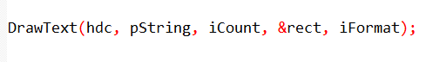

Arguments:

* hdc: Handle to the device context.
* pString: Pointer to the character string.
* iCount: Length of the string (-1 for NULL-terminated strings).
* &rect: Pointer to a rectangle structure defining the text area.
* iFormat: Flags controlling text formatting.

*The iFormat above has flags that control various aspects of text formatting. Here's a breakdown of each flag and its purpose:*

Alignment:

* DT_LEFT (default): Specifies left justification of the text.
* DT_RIGHT: Specifies right justification of the text.
* DT_CENTER: Specifies center alignment of the text.

Line Breaking:

* DT_SINGLELINE: Treats carriage returns and linefeeds as displayable characters, meaning they will be shown as they are.
* DT_TOP (default): Places the text at the top of the rectangle.
* DT_BOTTOM: Places the text at the bottom of the rectangle.
* DT_VCENTER: Vertically centers the text within the rectangle.
* DT_WORDBREAK: Breaks lines at the end of words if they don't fit within the rectangle. This ensures that words are not split in the middle.

Clipping:

* DT_NOCLIP: Disables clipping, allowing text to extend beyond the boundaries of the rectangle. This means the text may overflow outside the specified area.

Spacing:

* DT_EXTERNALLEADING: Includes external leading in line spacing. External leading refers to the extra space between lines of text.

Tabs:

* DT_EXPANDTABS: Expands tab characters (\t) to spaces, aligning the text based on the specified tab stops.
* DT_TABSTOP (use cautiously): Sets custom tab stops. The upper byte of iFormat specifies the positions of the tab stops. This flag should be used carefully, as incorrect tab stops can lead to inconsistent or unexpected text alignment.

These flags provide control over the alignment, line breaking, clipping, spacing, and tab behavior of the text. By combining different flags, you can achieve the desired formatting for displaying text within a given rectangle.

Key Points:

* Use ExtTextOut for granular control over clipping, background, and intercharacter spacing.
* Use DrawText for simplified text output within a rectangle, with various formatting options.
* Understand the available flags to tailor text output to your specific needs.
* Consider using DrawText for common text output tasks due to its convenience.
* Use ExtTextOut when you need precise control over text rendering.

Specifying Text within a Rectangle

Instead of specifying a coordinate starting position, DrawText uses a RECT structure defining a rectangle where the text should appear.

The function requires a pointer to the character string (pString) and its length (iCount). For NULL-terminated strings, setting iCount to -1 prompts Windows to calculate the length automatically.

Text Formatting Options

The iFormat argument in DrawText allows customization of the text's appearance within the specified rectangle.

Flags such as DT_LEFT (default for left-justified), DT_RIGHT (right-justified), and DT_CENTER (centered) control the horizontal alignment.

Including DT_SINGLELINE prevents newline characters, and DT_TOP, DT_BOTTOM, and DT_VCENTER dictate vertical alignment.

Handling Line Breaks and Word Wrapping

Windows interprets carriage return and linefeed characters as newline characters by default. The DT_SINGLELINE flag changes this behavior.

For multi-line displays, using DT_WORDBREAK breaks lines at the end of words, ensuring more readable text.

Additionally, the DT_NOCLIP flag prevents text truncation outside the specified rectangle.

Tab Handling

For text containing tab characters (\t or 0x09), including the DT_EXPANDTABS flag in DrawText ensures proper rendering.

By default, tab stops are set every eighth character position.

While the DT_TABSTOP flag allows custom tab settings, caution is advised due to potential conflicts with other flags in the iFormat argument.

In programming and character encoding, the term "tab character" refers to a control character that is commonly represented as \t in escape sequences or as the hexadecimal value 0x09. It is a non-printable character used to advance the cursor to the next tab stop.

When you encounter a tab character (\t or 0x09) in a string, it serves as an instruction to move the cursor to the next predefined position, which is typically at regular intervals.

The default convention is to set tab stops every eight character positions, but this can be customized.

DrawTextEx: Enhanced Text Handling with Tab Stops

Purpose:

* Offers more control over text formatting compared to DrawText, particularly for handling tab stops.
* Introduced to address limitations of DT_TABSTOP flag in DrawText.

Syntax:



Arguments:

* hdc: Handle to the device context.
* pString: Pointer to the character string.
* iCount: Length of the string.
* &rect: Pointer to a rectangle structure defining the text area.
* iFormat: Flags controlling text formatting (same as in DrawText).
* &drawtextparams: Pointer to a DRAWTEXTPARAMS structure for additional settings.

DRAWTEXTPARAMS Structure:

* cbSize: Size of the structure (set to sizeof(DRAWTEXTPARAMS)).
* iTabLength: Size of each tab stop, in units of average character width.
* iLeftMargin: Left margin, in units of average character width.
* iRightMargin: Right margin, in units of average character width.
* uiLengthDrawn: Receives the number of characters processed.

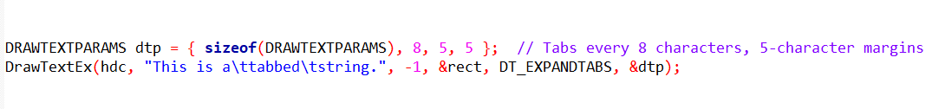Key Points:

* Use DrawTextEx when you need precise control over tab stops.
* Set iTabLength to define the spacing between tab stops.
* Margins are optional for further text positioning.
* uiLengthDrawn provides feedback on the amount of text drawn.
* Avoids conflicts with other flags in iFormat.
* DrawTextEx might not be available on older Windows systems.
* For simple tab handling without margins, DT_TABSTOP in DrawText might still suffice.
* Choose the appropriate function based on your specific tab stop requirements and compatibility needs.

Utilizing Enhanced Settings

With DrawTextEx, developers gain greater flexibility in text layout and formatting. The DRAWTEXTPARAMS structure allows for fine-tuning tab stops, adjusting margins, and obtaining information about the processed text.

This enhanced functionality is particularly valuable in scenarios where precise text alignment, tabulation, and margin control are essential.

By leveraging the DrawTextEx function with the DRAWTEXTPARAMS structure, developers can create visually appealing and precisely formatted text displays in Windows applications. This improved feature set contributes to a more robust and customizable text rendering experience.

DEVICE CONTEXT ATTRIBUTES FOR TEXT RENDERING IN WINDOWS

In Windows programming, several device context attributes play a crucial role in determining how text is displayed. These attributes allow developers to customize aspects such as text color, background color, background mode, and intercharacter spacing.

Customizing Text Color

The default text color in the device context is black, but developers can alter it using the SetTextColor function: Text Color is controlled by:

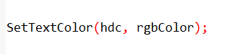

The rgbColor parameter represents the desired color, and Windows converts this value into a pure color. To retrieve the current text color, developers can use the GetTextColor function.

Background Mode and Color

Windows displays text within a rectangular background area, which can be colored based on the background mode setting. Developers can change the background mode using SetBkMode:

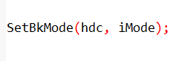

The iMode parameter can be either OPAQUE or TRANSPARENT. The default is OPAQUE, where Windows fills the background with the specified color. The background color can be set using:



The rgbColor parameter is converted to a pure color. In TRANSPARENT mode, Windows ignores the background color, enhancing text visibility.

Handling Intercharacter Spacing

Intercharacter spacing can be adjusted using the SetTextCharacterExtra function:

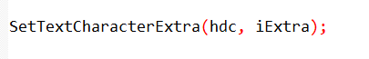

The iExtra parameter, in logical units, determines the spacing between characters. A value of 0 means no additional space.

Negative values are converted to their absolute values, preventing spacing less than 0. Developers can retrieve the current intercharacter spacing with GetTextCharacterExtra.

Adapting to System Colors

For consistency with system color settings, developers can set text and background colors using system colors:

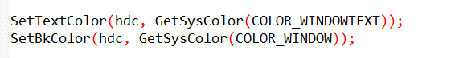

In case of system color changes, developers should handle the WM_SYSCOLORCHANGE message and update the display accordingly:

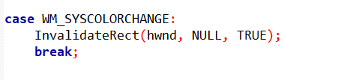

Understanding and manipulating these device context attributes provide developers with the tools needed to create visually appealing and adaptable text displays in Windows applications. Fine-tuning text color, background settings, and intercharacter spacing contribute to a more polished and user-friendly graphical interface.

Key Points:

* These attributes influence text appearance and background rendering.
* Choose appropriate settings for text readability and visual appeal.
* Consider system-consistent colors for seamless user experience.
* Adjust intercharacter spacing for fine-tuning text layout.

LEVERAGING STOCK FONTS FOR TEXT RENDERING IN WINDOWS

In Windows programming, the rendering of text is closely tied to the font selected in the device context.

While developers often need diverse fonts for displaying text, Windows provides a convenient solution through stock fonts.

Stock fonts are predefined fonts that offer a straightforward way to handle various typefaces and sizes.

Obtaining a Stock Font

To obtain a handle to a stock font, developers can use the GetStockObject function:

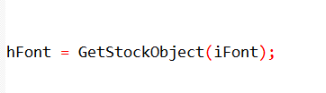

Here, iFont is one of several identifiers representing different stock fonts. The obtained font handle can then be selected into the device context using SelectObject:



Alternatively, these two steps can be combined into a single call:

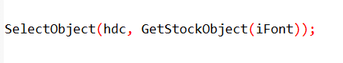

Understanding Font Roles and Selection:

Font Importance: Fonts play a vital role in text readability, visual appeal, and brand identity.

Stock Fonts: Quick Access: Windows offers a set of predefined stock fonts for immediate use, simplifying font selection for common scenarios.

Accessing Stock Fonts: The GetStockObject function retrieves a handle to a desired stock font, which is then selected into a device context using SelectObject.

Common Stock Fonts and Applications:

SYSTEM_FONT: The default proportional font, suitable for general text display.

SYSTEM_FIXED_FONT: A fixed-pitch font ensuring consistent character widths, often used for code listings or tabular data.

OEM_FIXED_FONT: The Terminal font, designed for compatibility with MS-DOS environments and legacy character sets.

DEFAULT_GUI_FONT: The font used in Windows UI elements like title bars, menus, and dialog boxes, ensuring visual consistency.

Font Metrics and Text Layout:

Measuring Fonts: The GetTextMetrics function provides essential information about a font's character height and average width, crucial for accurate text positioning and layout calculations.

Proportional Font Considerations: Proportional fonts have characters with variable widths, requiring careful consideration when determining text dimensions. Techniques for handling variable-width fonts will be discussed later.

Beyond Stock Fonts: Customization and Fine-Tuning:

Limitations: Stock fonts offer a limited range of choices and less control over specific typefaces and sizes.

Greater Flexibility: Windows provides font creation functions, discussed later, that enable you to precisely specify the desired typeface and size, unlocking a wider range of font possibilities.

Key Takeaways:

* Stock fonts offer a convenient starting point for basic font usage in Windows programming.
* Understanding their characteristics, limitations, and appropriate usage is essential for effective text rendering.
* For more precise control over font selection and customization, explore font creation functions to achieve the desired visual effects and text presentation.

UNDERSTANDING FONT BASICS IN WINDOWS

Before delving into specific code, it's crucial to establish a solid understanding of fonts in the Windows environment. Fonts play a pivotal role in text rendering, and Windows supports two main categories: "GDI fonts" and "device fonts."

Categories of Fonts

GDI Fonts:

Raster Fonts: Also known as bitmap fonts, these fonts store each character as a bitmap pixel pattern. They are designed for specific aspect ratios and character sizes. Raster fonts are "nonscaleable," meaning they cannot be expanded or compressed arbitrarily. They are fast to display and legible.

* Characters stored as bitmaps.
* Limited scalability.
* Design-specific sizes and aspect ratios.
* Fast display and high readability.
* Common typefaces: System, FixedSys, Terminal, Courier, MS Serif, MS Sans Serif, Small Fonts.

Stroke Fonts: Defined as a series of line segments in a "connect-the-dots" format, stroke fonts are continuously scalable. However, their performance is poorer, legibility suffers at small sizes, and characters may appear weak at large sizes. Stroke fonts include Modern, Roman, and Script.

* Defined by line segments.
* Continuously scalable.
* Lower performance and legibility concerns.
* Suitable for plotters.
* Common typefaces: Modern, Roman, Script.

TrueType Fonts:

* Outline-based, scalable to any size.
* High quality and visual appeal.
* Widely used in modern Windows systems.

Device Fonts:

Native to output devices like printers, these fonts are built into the hardware. Printers often have a collection of device fonts.

Typeface Names:

* System Font: Typeface name is "System," used for SYSTEM_FONT.
* System Fixed Font: Typeface name is "FixedSys," used for SYSTEM_FIXED_FONT.
* OEM Fixed Font (Terminal): Typeface name is "Terminal," used for OEM_FIXED_FONT.
* Courier: A fixed-pitch font resembling typewriter text.
* MS Serif and MS Sans Serif: Used for DEFAULT_GUI_FONT. "Serif" fonts have small turns finishing strokes, while "sans serif" fonts lack serifs.
* Small Fonts: Specifically designed for displaying text in small sizes.

Font Attributes/Characteristics:

* Typeface: The design of the characters (e.g., Times New Roman, Arial).
* Size: Measured in points (e.g., 12pt).
* Weight: Regular, bold, or light.
* Style: Normal, italic, or oblique.
* Synthesized Attributes: Windows can create bold, italic, underlined, and strikethrough effects without separate fonts.

Key Considerations for Font Selection:

* Readability: Raster fonts often excel in clarity and legibility.
* Scalability: TrueType fonts offer flexibility for various sizes and resolutions.
* Performance: Raster fonts display faster, while TrueType fonts may require more processing.
* Visual Appeal: TrueType fonts generally provide superior aesthetics and design variety.
* Device Compatibility: Device fonts are specific to output devices, while GDI fonts offer broader compatibility.

TrueType Fonts

TrueType fonts constitute a significant part of Windows font capabilities. Unlike raster fonts and stroke fonts, TrueType fonts offer scalability without compromising legibility.

TrueType fonts will be explored in greater detail in subsequent sections. Combine advantages of scalability and visual quality.

OpenType fonts, a later extension of TrueType, offer additional features and cross-platform compatibility.

Font Attributes Synthesis

For both GDI raster fonts and GDI stroke fonts, Windows can synthesize attributes like boldface, italics, underlining, and strikethrough without storing separate fonts for each variant. For example, to achieve italics, Windows shifts the upper part of the character to the right.

Essential Takeaways:

* Windows supports a diverse range of font technologies to meet different needs.
* Understanding the characteristics and trade-offs of each font type is crucial for effective font selection and usage.
* TrueType fonts have become the dominant choice in contemporary Windows environments due to their versatility and visual appeal.

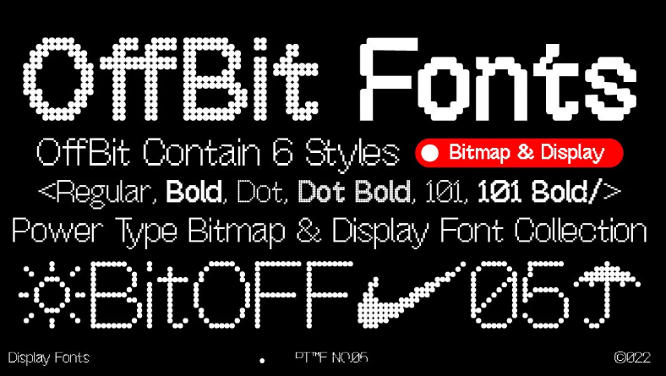 Raster font.

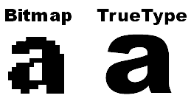 True type font.

EXPLORING TRUETYPE FONTS IN WINDOWS

TrueType fonts represent a significant advancement in font technology, offering scalable and detailed characters defined by filled outlines of straight lines and curves. Understanding how TrueType fonts work is crucial for effective utilization in Windows programming.

Characteristics of TrueType Fonts

Character Definition:

TrueType fonts define individual characters through filled outlines of straight lines and curves.

These fonts can be scaled by altering the coordinates that define the outlines.

Rasterization Process:

When a program begins using a TrueType font at a specific size, Windows engages in a process called "rasterization."

Rasterization involves scaling the coordinates of lines and curves in each character based on hints embedded in the TrueType font file.

These hints compensate for rounding errors, ensuring characters maintain their intended appearance.

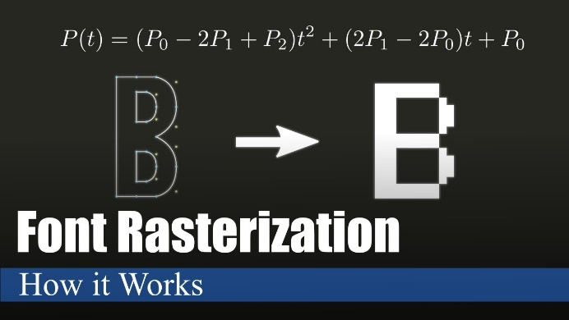

Bitmap Creation:

The scaled outlines of characters are used to create bitmaps for each character.

These bitmaps are cached in memory for future use, contributing to improved performance.

Key Characteristics in summary:

Outline-Based: Characters defined by mathematical outlines of lines and curves, ensuring smooth scaling and high visual quality.

Scalability: Can be expanded or reduced to any size without losing clarity, offering versatility in design and output.

Hints: Embedded instructions within font files guide scaling and rendering for optimal appearance, preventing distortions and preserving design integrity.

Rasterization: Windows converts TrueType outlines to bitmaps for display and printing, balancing visual appeal with performance.

Caching: Frequently used bitmaps are stored in memory for faster retrieval, reducing processing overhead.

Common TrueType Fonts in Windows:

Courier New: Fixed-pitch font resembling typewriter output.

Times New Roman: Highly readable serif font, popular for printed material.

Arial: Versatile sans-serif font, suitable for screens and print.

Symbol: Contains a collection of symbols and characters for specialized use.

Lucida Sans Unicode: Includes a wider range of global alphabets for multilingual support.

Symbol

In recent Windows versions, the list has expanded, with additional fonts like Lucida Sans Unicode, catering to diverse alphabets used globally.

Advantages:

* Versatility: Adaptable to various sizes and output devices.
* Visual Quality: Smooth outlines and careful rendering produce crisp, professional-looking text.
* Readability: Well-designed TrueType fonts enhance text clarity and ease of reading.
* Aesthetics: Offer a wide range of creative font styles and designs for visual appeal.

Considerations:

* Processing Overhead: Rasterization can require more processing compared to raster fonts.
* Font Availability: Not all fonts are available in TrueType format.

Overall, TrueType fonts have become the dominant font technology in modern Windows environments due to their flexibility, visual appeal, and widespread support across devices and applications.

RECONCILING TRADITIONAL AND COMPUTER TYPOGRAPHY:s

Windows' Adaptive Approach: Navigates the subtle distinctions between traditional typography's emphasis on distinct font styles and computer typography's attribute-based approach by supporting both methods of font selection. This flexibility empowers developers to align with specific needs or preferences for font management.

Point Size: A Design Guideline, Not a Precise Ruler:

While point size serves as a foundation for font sizing, it's crucial to recognize its role as a typographic concept rather than a rigid measurement.

Actual character dimensions within a font can deviate from expectations based on point size alone.

This underscores the importance of utilizing GetTextMetrics for accurate character measurements in computer typography.

Historical Context: The point, approximately 1/72 of an inch, originates from traditional print typography and is now a digital fixture for font sizing. However, its role as a guide rather than a strict measure highlights the nuances of font design and rendering across different technologies.

Leading: Orchestrating Vertical Harmony:

Internal Leading: Space for Diacritics: This design element within a font accommodates diacritics (accents) that often extend above or below the standard character height, ensuring proper visual balance.

External Leading: Guiding Line Spacing: The TEXTMETRIC structure's tmExternalLeading value offers a suggestion for spacing between lines of text, promoting readability and visual rhythm. Developers can directly utilize this value or adjust it based on specific design requirements.

TextMetrics for Accurate Metrics: This essential function provides a detailed look at font metrics, including tmHeight (representing line spacing rather than precise font size), tmInternalLeading, and tmExternalLeading. Leveraging this information is crucial for achieving accurate text layout and spacing in digital environments.

Beyond the Basics: Embracing the Art and Science of Typography:

Font Design Nuances: Font designers carefully consider character proportions and leading values to achieve a balance between readability, visual appeal, and the intended tone of the text. These considerations are important when selecting fonts and presenting text effectively.

Balancing Conventions and Technical Metrics: Successful text rendering requires a blend of typographic conventions and the technical aspects of font metrics in digital systems. Understanding this interplay is crucial for creating visually pleasing and professional-looking documents.

Experimentation and Exploration: The world of fonts offers a wide range of diversity and expressive possibilities. By exploring different font families, styles, sizes, leading, and spacing, you can discover combinations that align with your design goals and enhance the overall user experience.

ADDRESSING THE LOGICAL INCH CONUNDRUM IN WINDOWS DISPLAY

In a previous discussion in Chapter 5, we delved into the intricacies of the system font in Windows 98, highlighting its definition as a 10-point font with 12-point line spacing.

The choice between Small Fonts and Large Fonts in Display Properties dictated the tmHeight value, impacting the pixel resolution and resulting in an implied resolution of either 96 dpi or 120 dpi.

This implied resolution is ascertainable through GetDeviceCaps with LOGPIXELSX or LOGPIXELSY arguments, denoting the dots per inch.

The Logical Inch Phenomenon

The concept of a "logical inch" emerges, representing the metrical distance occupied by 96 or 120 pixels on the screen.

When measured with a ruler, a logical inch often appears larger than an actual inch.

This discrepancy stems from the need to display legible 8-point type on the screen, considering factors like readability and typical viewing distances.

In typography, 8-point type on paper, with approximately 14 characters per inch, is easily readable.

Translating this to a video display directly might result in insufficient pixel density for legible characters.

The logical inch acts as a magnification factor, facilitating the display of legible fonts, even as small as 8 points.

Additionally, the logical inch takes advantage of the screen width, aligning with standard paper margins and optimizing text display.

Concept: A unit of measurement introduced to ensure legible font display on screens, even when physical pixel density might be insufficient for small type sizes.

Purpose:

* Enables readable text sizes (e.g., 8-point) on various display resolutions.
* Accounts for typical viewing distances from screens (usually further than reading print on paper).
* Optimizes display width for text layout, aligning with standard paper margins.

Windows NT Distinction

Windows NT introduces some variations in its approach.

Unlike Windows 98, the LOGPIXELSX and LOGPIXELSY values in Windows NT are not equivalent to pixel count divided by size in millimeters, multiplied by 25.4.

While Windows uses HORZRES, HORZSIZE, VERTRES, and VERTSIZE values for mapping modes, programs displaying text are better off assuming a display resolution based on LOGPIXELSX and LOGPIXELSY.

Windows 98:

* System font defined as 10-point with 12-point line spacing.
* "Small Fonts" setting implies 96 dots per logical inch (dpi).
* "Large Fonts" setting implies 120 dpi.
* Obtain logical dpi using GetDeviceCaps(hdc, LOGPIXELSX) or GetDeviceCaps(hdc, LOGPIXELSY).

Windows NT:

* Inconsistency between LOGPIXELS values and actual display dimensions.
* Recommended to use logical dpi for text display, aligning with Windows 98 behavior.
* Create custom mapping mode (e.g., "Logical Twips") for consistent text handling.

Introducing the "Logical Twips" Mapping Mode

Given the disparities, a program under Windows NT might opt for a custom mapping mode aligned with logical pixels per inch, similar to Windows 98.

One such mapping mode, termed "Logical Twips," involves the following setup:

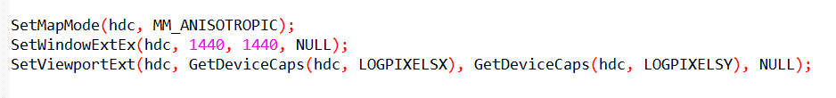

In this mode, font dimensions can be specified in 20 times the point size (e.g., 240 for 12 points). Notably, the y-values increase downward, enhancing the display of successive lines of text.

Mapping Modes and Text Consistency:

Windows 98: Predefined mapping modes generally work well for text display.

Windows NT:

* Avoid default mapping modes for text due to inconsistencies.
* Define a custom mapping mode like "Logical Twips" to ensure consistent text sizing and positioning across different Windows versions.

Key Points:

* Logical inch often larger than an actual inch, intentionally magnifying text for better readability on screens.
* 640-pixel minimum display width at 96 dpi closely aligns with 8.5-inch paper width with standard margins.
* Discrepancy between logical and real inches only applies to displays; printers maintain consistency between GDI measurements and physical dimensions.

Additional Considerations:

User Feedback: Consider incorporating user preferences for font size and display settings to enhance readability and accessibility.

Modern Systems: While logical inch concept remains relevant, newer Windows versions and high-resolution displays may offer alternative approaches to font scaling and display optimization.

It's crucial to recognize that the logical inch vs. real inch inconsistency is specific to the display, and on printer devices, consistency prevails with GDI and rulers.

This nuanced understanding is imperative for accurate and visually appealing text rendering in Windows programming.

UNDERSTANDING LOGICAL FONTS:

Abstract Descriptions: Logical fonts act as blueprints for text appearance, defining characteristics like typeface, size, weight, and style.

GDI Objects: They are handles of type HFONT, created and managed by the Windows Graphics Device Interface (GDI).

Device Independence: Logical fonts bridge the gap between desired text styles and device-specific font capabilities, ensuring consistent text rendering across different displays and printers.

* A logical font, encapsulated in a GDI object with a handle of type HFONT, serves as a descriptor for a font. Much like logical pens and logical brushes, it remains an abstract entity until selected into a device context using SelectObject. This selection process solidifies its existence, and only then does Windows gain awareness of the device's font capabilities.

Creating and Selecting Logical Fonts

Logical fonts come into existence through the invocation of either CreateFont or CreateFontIndirect.

While CreateFont takes 14 individual arguments, mirroring the fields of a LOGFONT structure, CreateFontIndirect receives a pointer to a LOGFONT structure with these 14 fields.

*Creating a LOGFONT structure for CreateFontIndirect involves three primary approaches:*

Direct Specification: Set the fields of the LOGFONT structure to the desired font characteristics. However, Windows employs a "font mapping" algorithm during SelectObject, attempting to provide the closest match available on the device.

Enumeration: Enumerate all fonts on the device, allowing you to choose from or present them to the user. Font enumeration functions exist for this purpose, although they are less common nowadays due to a more automated alternative.

ChooseFont Function: Utilize the ChooseFont function, which returns a LOGFONT structure, streamlining the font selection process.

In this discussion, the focus will be on the first and third approaches.

The lifecycle of a logical font involves three key steps:

*Steps for Handling Logical Fonts:*

Create: Use CreateFontIndirect (or CreateFont) to generate a logical font based on desired attributes.

Select: Employ SelectObject to activate the logical font in a device context. Windows maps it to a suitable real font.

Query: Obtain detailed information about the selected real font using GetTextMetrics and GetTextFace functions.

Utilize: Draw text with the selected font.

Delete: Call DeleteObject to remove the logical font when finished (not applicable to stock fonts or those still selected in a DC).

Creation:

Initiate a logical font using CreateFont or CreateFontIndirect. These functions yield a handle to an HFONT.

CreateFontIndirect:

* Preferred function for creating logical fonts.
* Takes a pointer to a LOGFONT structure specifying font attributes.

ChooseFont:

* Simplifies font selection by presenting a user-friendly dialog.
* Returns a LOGFONT structure with user-specified attributes.

Selection:

Select the logical font into the device context with SelectObject. Windows, in turn, chooses a real font that closely matches the logical font.

Deletion:

After utilizing the font, delete it by invoking DeleteObject. It's crucial to avoid deleting the font while it is selected in a valid device context and refrain from deleting stock fonts.

Font Mapping:

Key Process: Windows matches a logical font to the closest available real font on the device when selected into a device context.

Possible Variance: The actual font displayed or printed might differ slightly from the requested logical font, depending on device-specific font availability.

Structures for Font Information:

LOGFONT: Defines font attributes during creation (14 fields, including typeface, size, weight, style, etc.).

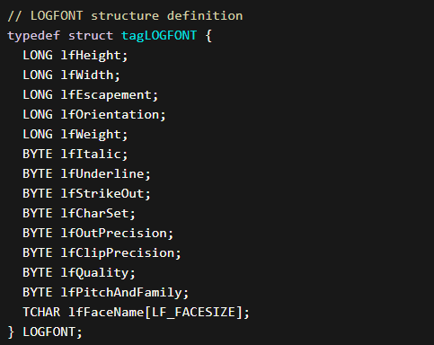

Key Considerations:

* Font Availability: Be mindful of device-specific font limitations and potential variations in rendering.
* User Preferences: Consider incorporating user choices for font styles and sizes to enhance readability and accessibility.
* Font Families: Explore font families with broad availability to increase the likelihood of consistent rendering across devices.
* Modern Font Technologies: Stay updated on advancements in font rendering and management for optimal text presentation in contemporary Windows environments.

TEXTMETRIC: Retrieves information about the currently selected font in a device context (20 fields, including size metrics, character spacing, etc.).

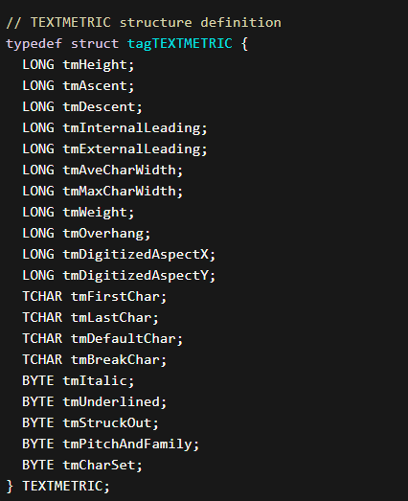

Extracting Font Information

To discern the face name of the font currently in the device context, GetTextFace proves useful:



For detailed font information, the GetTextMetrics function comes into play:



PICKFONT PROGRAM

Overview of "PICKFONT.C" Program Sections:

Structure Definition:

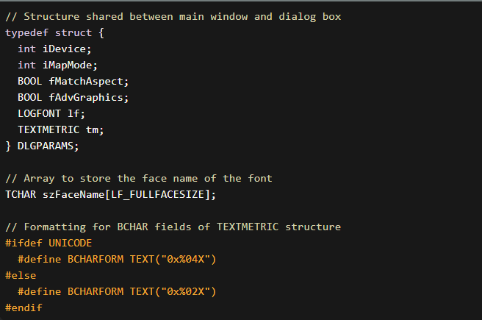

In the "PICKFONT.C" program, the "Structure Definition" section plays a crucial role in organizing and encapsulating the parameters necessary for handling device information, font characteristics, and flags.

The structure defined, named DLGPARAMS, serves as a container to hold diverse data elements that are essential for the program's functionality.

The DLGPARAMS structure includes several fields that collectively store information related to the font creation process.

These fields cover aspects such as the selected device (screen or printer), font attributes (like height, width, escapement, etc.), and flags indicating whether certain advanced graphics features are enabled.

Additionally, a boolean field, fMatchAspect, is present to signify whether the aspect ratio should be matched.

Furthermore, the structure features an array named szFaceName, designed to store the face name of the font.

This array is crucial for preserving the user's choice of font style and ensuring that the selected font is accurately represented in the program.

The inclusion of such a structure enhances the program's modularity and readability by consolidating related pieces of information into a single, well-defined entity.

In essence, the "Structure Definition" section establishes the blueprint for organizing and managing the program's data, promoting a clean and structured approach to handling the diverse parameters associated with font creation and display.

The use of a structured format not only facilitates ease of access and modification but also contributes to the overall clarity and maintainability of the code.

Global Variables

In the "Global Variables" section of the "PICKFONT.C" program, various global variables are declared. Let's break down each element:

hwnd (Main Window Handle):

The hwnd variable is of type HWND, which stands for "window handle." In the Windows API, a window handle is a unique identifier for a graphical window. This variable is used to store the handle of the main window created by the program.



hdlg (Dialog Box Handle):

The hdlg variable, also of type HWND, is used to store the handle of the dialog box created in the program. This handle allows the program to interact with and control the dialog box.



szAppName (Application Name):

The szAppName variable is an array of characters (of type TCHAR) representing the name of the application. It is initialized with the string "PickFont." The TEXT macro is used to make the string compatible with both Unicode and ANSI character sets.



*These global variables play essential roles in the program:*

* Window Handles (hwnd and hdlg): Window handles are crucial for interacting with different parts of the graphical user interface (GUI). The main window handle (hwnd) is used to manage the main window, while the dialog box handle (hdlg) is employed for interacting with the dialog box and its components.
* Application Name (szAppName): The application name is a human-readable identifier for the program. It can be used in various places, such as window class registration, message boxes, and menu items.

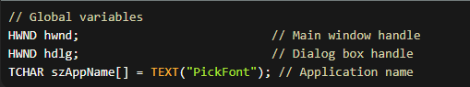

By declaring these variables globally, they can be accessed and modified throughout the program, allowing for communication between different parts of the code, such as the main window procedure (WndProc) and the dialog box procedure (DlgProc).

Global variables are often used in Windows programming to maintain state and share information between different components of a graphical application.

Forward Declarations: Declares forward functions, WndProc, DlgProc, SetLogFontFromFields, SetFieldsFromTextMetric, and MySetMapMode.

WinMain function:

The WinMain function serves as the entry point for the program, orchestrating the initialization, execution, and termination phases. Below is an in-depth explanation of each part of the WinMain function:

Registering Window Class:

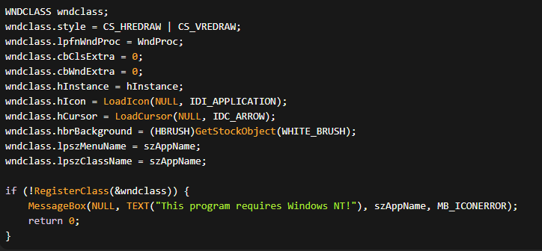

In this code snippet, a WNDCLASS structure named wndclass is defined. Its members are set as follows:

* style is set to CS_HREDRAW | CS_VREDRAW, which enables the window to be redrawn when its width or height changes.
* lpfnWndProc is set to WndProc, which is the callback function that handles window messages.
* cbClsExtra and cbWndExtra are both set to 0, indicating no extra bytes are allocated for the class and window instances.
* hInstance is set to the value of the hInstance parameter, which represents the instance handle of the application.
* hIcon is set to the icon associated with the application, loaded using LoadIcon() with NULL as the first parameter and IDI_APPLICATION as the icon identifier.
* hCursor is set to the cursor associated with the application, loaded using LoadCursor() with NULL as the first parameter and IDC_ARROW as the cursor identifier.
* hbrBackground is set to the white brush obtained from GetStockObject(WHITE_BRUSH).
* lpszMenuName is set to szAppName, which is the application name stored as a TCHAR array.
* lpszClassName is also set to szAppName.
* Finally, the code checks if the class registration was successful using RegisterClass(). If not, a message box is displayed indicating that the program requires Windows NT, and the program returns 0.

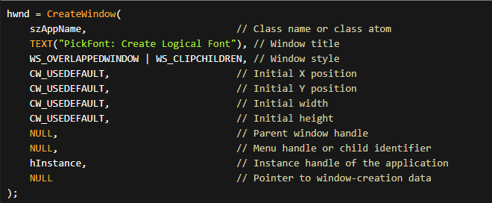

* szAppName is the name of the window class previously registered with RegisterClass.
* "PickFont: Create Logical Font" is the window title.
* WS_OVERLAPPEDWINDOW | WS_CLIPCHILDREN specifies the window style, which includes features such as a title bar, sizing border, system menu, and minimize/maximize buttons. The WS_CLIPCHILDREN style is used to ensure that child windows are not drawn outside the boundaries of the parent window.
* CW_USEDEFAULT is used for the initial position and size of the window, which allows the system to choose the default values.
* NULL specifies the parent window handle since this is a top-level window.
* NULL specifies the menu handle, as no menu is associated with the window.
* hInstance is the instance handle of the application.
* NULL is passed as the last parameter, which is reserved for future use.

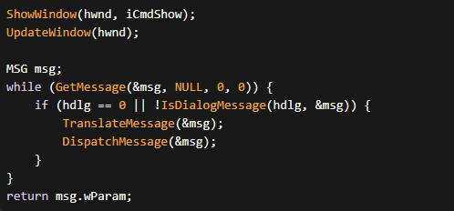

* ShowWindow(hwnd, iCmdShow): Displays the main window based on the specified iCmdShow parameter (e.g., SW_SHOWNORMAL).
* UpdateWindow(hwnd): Sends a WM_PAINT message to the main window, prompting it to paint its client area.
* The subsequent while loop runs the message loop, processing messages until a WM_QUIT message is received.
* GetMessage(&msg, NULL, 0, 0): Retrieves a message from the message queue.
* If there is a dialog box (hdlg) and the message is a dialog message, it is processed by IsDialogMessage to ensure proper handling.
* TranslateMessage(&msg): Translates virtual-key messages into character messages.
* DispatchMessage(&msg): Sends the message to the window procedure (WndProc) for processing.
* The function returns when a WM_QUIT message is received, and the program exits with the wParam from that message.

WndProc function:

The WndProc function serves as the window procedure for the main window, managing various messages that the window receives during its lifetime. Let's break down the key aspects of this function in depth:

Initialization and Dialog Box Creation:

*DlgProc Function:*

* Handles messages for the dialog box.
* Manages initialization, user input, and updates font information based on user selections.
* Invokes SetLogFontFromFields and SetFieldsFromTextMetric functions.

SetLogFontFromFields Function:

Extracts font attributes from dialog box fields and updates the LOGFONT structure in DLGPARAMS.

SetFieldsFromTextMetric Function:

Updates dialog box fields with information obtained from the TEXTMETRIC structure in DLGPARAMS.

MySetMapMode Function:

Sets the mapping mode for the device context based on the user's selection in the dialog box.

Message Handling:

Handles various messages, such as initialization, focus, command input, painting, and destruction of windows and dialog boxes.

Constants and Macros:

Defines constants, resource IDs, and formatting macros used in the program.

Note: The program primarily focuses on creating a logical font based on user input through a dialog box and displaying the resulting font on the main window. The dialog box allows users to customize font attributes and select the device type. The program emphasizes the interaction between the main window and the dialog box for font creation and display.